We need to execute below command as per the README.md file in “chaper02” folder:

wget https://downloads.graphaware.com/neo4j-the-definitive-guide/dataset.zip

It failed in Docker Desktop as follows:
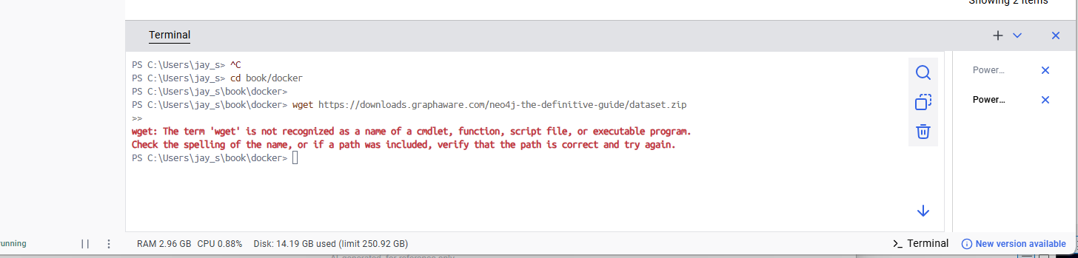

So I ran it in WSL command line mode, first launch WSL as follows: [if don’t have WSL follow the steps given after this]
C:\Users\jay_s>wsl
Welcome to Ubuntu 24.04.1 LTS (GNU/Linux 5.15.153.1-microsoft-standard-WSL2 x86_64)

* Documentation: https://help.ubuntu.com
* Management: https://landscape.canonical.com
* Support: https://ubuntu.com/pro

System information as of Tue Oct 14 16:20:06 EDT 2025

System load: 1.47 Processes: 63
Usage of /: 0.2% of 1006.85GB Users logged in: 0
Memory usage: 19% IPv4 address for eth0: 172.21.109.38
Swap usage: 0%

* Strictly confined Kubernetes makes edge and IoT secure. Learn how MicroK8s
just raised the bar for easy, resilient and secure K8s cluster deployment.

https://ubuntu.com/engage/secure-kubernetes-at-the-edge

This message is shown once a day. To disable it please create the
/root/.hushlogin file.
root@Samsung-T1NC705:/mnt/c/Users/jay_s#

root@Samsung-T1NC705:/mnt/c/Users/jay_s# cd book

root@Samsung-T1NC705:/mnt/c/Users/jay_s/book# wget https://downloads.graphaware.com/neo4j-the-definitive-guide/dataset.zip

--2025-10-14 16:24:06-- https://downloads.graphaware.com/neo4j-the-definitive-guide/dataset.zip
Resolving downloads.graphaware.com (downloads.graphaware.com)... 13.33.82.91, 13.33.82.109, 13.33.82.117, ...
Connecting to downloads.graphaware.com (downloads.graphaware.com)|13.33.82.91|:443... connected.
HTTP request sent, awaiting response... 200 OK
Length: 5384099128 (5.0G) [application/zip]
Saving to: ‘dataset.zip’

dataset.zip 100%[====================================================>] 5.01G 20.0MB/s in 4m 40s

2025-10-14 16:28:47 (18.3 MB/s) - ‘dataset.zip’ saved [5384099128/5384099128]

We can see the “dataset.zip” file was downloaded.
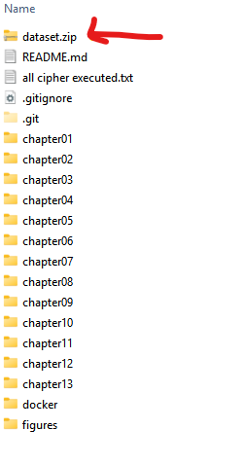
I opened the zip file to see what files inside the folder:
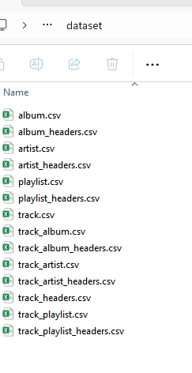
I might have to copy them to “import” [ C:\Users\jay_s\book\docker] folder when I am importing them to the database that I am going to use for “chapter02” cipher queries.

If you still want to run that command in your PowerShell window in your Docker Desktop follow the steps below to do it:

The error occurs because wget isn't natively available in Windows PowerShell. wget is a command-line utility for downloading files from the web primarily used in Linux/Unix systems. Here's what you should know:

What is wget?
- Full name: GNU Wget (World Wide Web get)
- Purpose: Non-interactive network downloader
- Origin: Linux/Unix command-line tool
- Functionality: Downloads files from HTTP, HTTPS, and FTP protocols

Key Features of wget:
- Resume interrupted downloads
- Download entire websites (recursive downloading)
- Work in background
- Handle authentication (username/password)
- Support for proxies

Why it didn't work in your PowerShell:
- Windows PowerShell doesn't include wget by default
- What you might have seen is that some systems have a wget alias that points to Invoke-WebRequest

Cross-Platform Comparison:
System | Command | Example
Linux/Mac | wget | wget https://example.com/file.zip
Windows PowerShell | Invoke-WebRequest | iwr https://example.com/file.zip -OutFile file.zip
Windows (if wget alias exists) | wget | wget https://example.com/file.zip -OutFile file.zip

How to get real wget on Windows:
- Install via Chocolatey: choco install wget
- Install via WSL (Windows Subsystem for Linux)
- Use Git Bash (includes wget)
- Download GNUWin32 version

Here are several ways to download that file in PowerShell:
Method 1: Use PowerShell's Invoke-WebRequest (Recommended)
Invoke-WebRequest -Uri "https://downloads.graphaware.com/neo4j-the-definitive-guide/dataset.zip" -OutFile "dataset.zip"

Method 2: Use the alias iwr (shorter version)
iwr "https://downloads.graphaware.com/neo4j-the-definitive-guide/dataset.zip" -OutFile "dataset.zip"

Method 3: If you prefer wget-like syntax, use wget alias
First, check if the alias exists:
Get-Alias wget

If it exists (it often does in newer PowerShell versions), you can use:
wget "https://downloads.graphaware.com/neo4j-the-definitive-guide/dataset.zip" -OutFile "dataset.zip"

Method 4: For Docker Desktop context
If you're planning to use this with Docker, you might want to download it directly into your project directory, then use it in your Docker container. Here's a complete example:

# Download the dataset
Invoke-WebRequest -Uri "https://downloads.graphaware.com/neo4j-the-definitive-guide/dataset.zip" -OutFile "dataset.zip"

# Extract if needed (optional)
Expand-Archive -Path "dataset.zip" -DestinationPath "." -Force

Additional Tips:
- The download will show a progress bar
- The file will be saved in your current directory (C:\Users\jay_s\)
- You can verify the download with: Get-ChildItem dataset.zip

Try Method 1 first - it's the most reliable approach in Windows PowerShell.

Once you download the dataset, you need to execute the below command as per the “admin-import.md” file:
```bash
./bin/neo4j-admin database import full book \
--nodes=:Track=import/full/track_headers.csv,import/full/track.csv \
--nodes=:Playlist=import/full/playlist_headers.csv,import/full/playlist.csv \
--nodes=:Artist=import/full/artist_headers.csv,import/full/artist.csv \
--nodes=:Album=import/full/album_headers.csv,import/full/album.csv \
--relationships=ARTIST=import/full/track_artist_headers.csv,import/full/track_artist.csv \
--relationships=HAS_TRACK=import/full/track_playlist_headers.csv,import/full/track_playlist.csv \
--relationships=HAS_TRACK=import/full/track_album_headers.csv,import/full/track_album.csv \
--skip-duplicate-nodes --skip-bad-relationships=true --multiline-fields=true --verbose
```

This command imports data into a Neo4j graph database using the neo4j-admin import tool. It performs a full database import of music-related data into a Neo4j database named "book".

Components Breakdown:
Database & Import Type
- ./bin/neo4j-admin database import full book
  - Uses Neo4j's admin tool for a full database import (replaces existing data)
  - Creates/imports into a database named "book"
Node Creation (4 types of nodes)
- Track nodes (:Track)
  - Headers: import/full/track_headers.csv
  - Data: import/full/track.csv
- Playlist nodes (:Playlist)
  - Headers: import/full/playlist_headers.csv
  - Data: import/full/playlist.csv
- Artist nodes (:Artist)
  - Headers: import/full/artist_headers.csv
  - Data: import/full/artist.csv
- Album nodes (:Album)
  - Headers: import/full/album_headers.csv
  - Data: import/full/album.csv
Relationship Creation (3 types of relationships)
- ARTIST relationships
  - Connects tracks to artists
  - Files: track_artist_headers.csv + track_artist.csv
- HAS_TRACK relationships (for playlists)
  - Connects playlists to tracks
  - Files: track_playlist_headers.csv + track_playlist.csv
- HAS_TRACK relationships (for albums)
  - Connects albums to tracks
  - Files: track_album_headers.csv + track_album.csv
Import Options
- --skip-duplicate-nodes: Ignores duplicate nodes during import
- --skip-bad-relationships=true: Skips invalid relationships instead of failing
- --multiline-fields=true: Supports CSV fields that span multiple lines
- --verbose: Shows detailed progress information

Important Notes:
- This is for initial database setup (not for incremental updates)
- The database must be stopped during this operation
- All existing data in the "book" database will be replaced
- CSV files must follow Neo4j's import format with proper headers
This is typically used for bulk loading large datasets efficiently into a new Neo4j database.

First stop the database using docker command as follows:

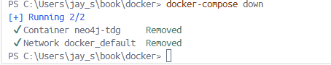

Your browser look like this now:
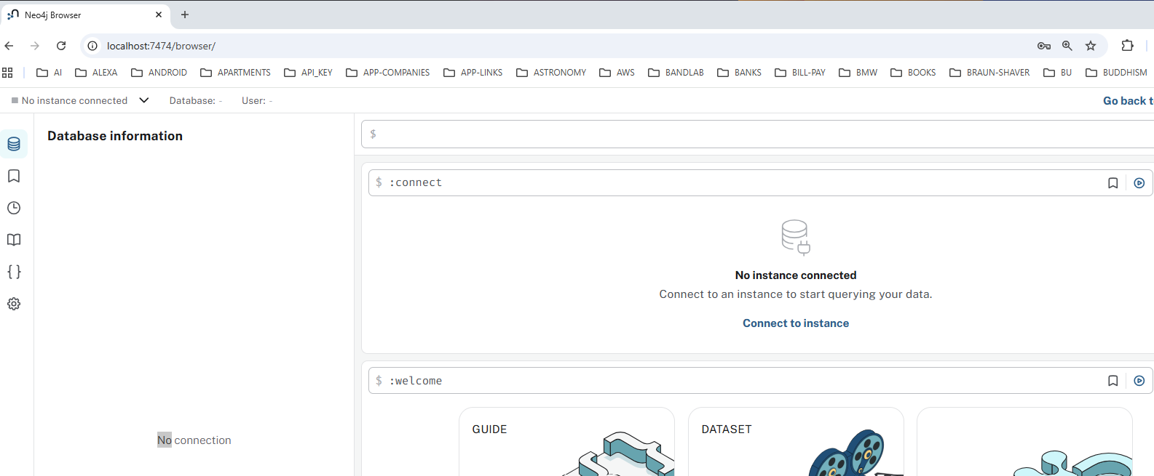

Why it won't work directly on PowerShell:
- neo4j-admin is a Neo4j-specific command that only exists inside a Neo4j container
- The paths (./bin/neo4j-admin, import/full/) are relative to the Neo4j installation
- This command must run inside a Neo4j container

Prerequisites:
- Your CSV files must be in the correct location:
  - They should be in an import/full/ directory on your host
  - Mounted to the container via volumes
- Neo4j must be stopped during admin imports
- File structure should look like:

your-project/
├── import/
│ └── full/
│ ├── track_headers.csv
│ ├── track.csv
│ ├── artist_headers.csv
│ ├── artist.csv
│ └── ... etc.

First I copy the content of “dataset.zip” file to the below folder location:
C:\Users\jay_s\book\docker\import\full

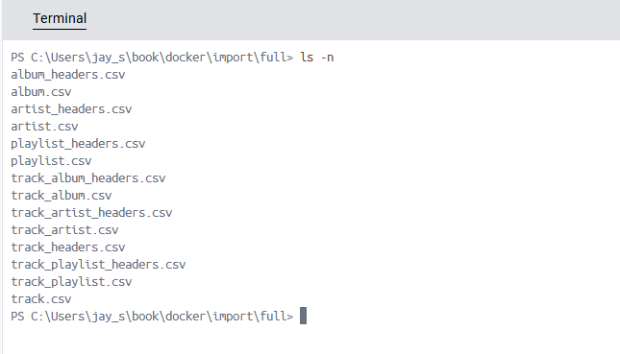

Quick test to verify:
PS C:\Users\jay_s\book\docker> GEt-ChildItem import/full/*.csv

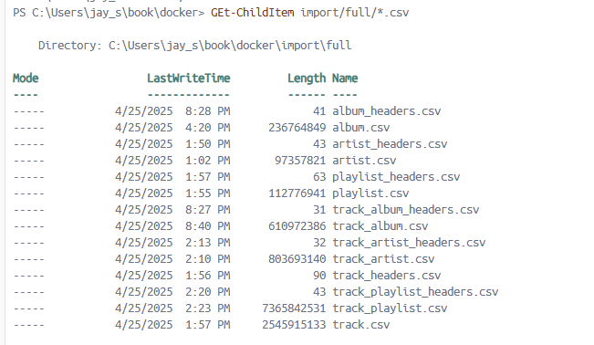

PS C:\Users\jay_s\book\docker> docker run -it -v ${PWD}/import:/import neo4j:latest ls -la /import/full/

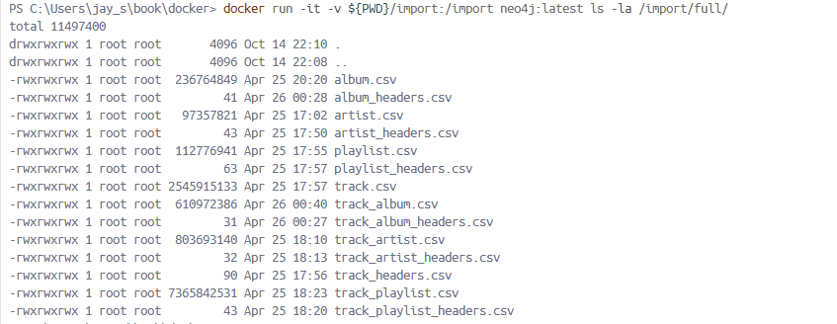

First stop all neo4j containers running. You can find them using the commands below:
PS C:\Users\jay_s\book\docker> docker ps -a
PS C:\Users\jay_s\book\docker> docker ps -a | findstr "neo4j"

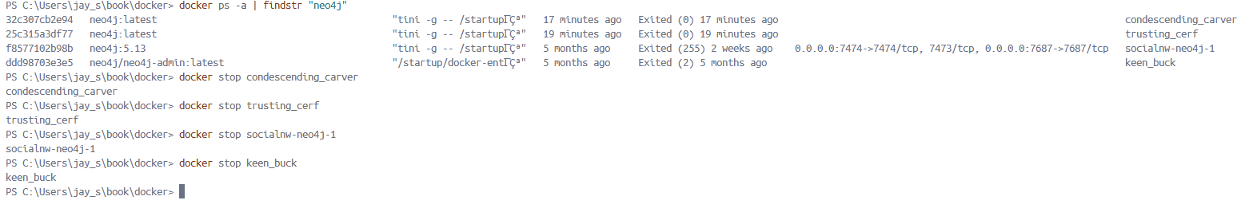

Also check:
PS C:\Users\jay_s\book\docker> docker compose ps
NAME IMAGE COMMAND SERVICE CREATED STATUS PORTS
PS C:\Users\jay_s\book\docker> docker compose ps -a
NAME IMAGE COMMAND SERVICE CREATED STATUS PORTS
PS C:\Users\jay_s\book\docker> docker compose stop

How to properly run this import task:
If using Docker containers:
Option 1: Use a temporary container for import

# Stop and remove any running Neo4j container
docker stop neo4j-container // you could have different neo4j containers
docker rm neo4j-container

docker run --rm `
-v ${PWD}/import:/import `
-v ${PWD}/data:/data `
neo4j:latest `
./bin/neo4j-admin database import full book `
--nodes=:Track=import/full/track_headers.csv,import/full/track.csv `
--nodes=:Playlist=import/full/playlist_headers.csv,import/full/playlist.csv `
--nodes=:Artist=import/full/artist_headers.csv,import/full/artist.csv `
--nodes=:Album=import/full/album_headers.csv,import/full/album.csv `
--relationships=ARTIST=import/full/track_artist_headers.csv,import/full/track_artist.csv `
--relationships=HAS_TRACK=import/full/track_playlist_headers.csv,import/full/track_playlist.csv `
--relationships=HAS_TRACK=import/full/track_album_headers.csv,import/full/track_album.csv `
--skip-duplicate-nodes --skip-bad-relationships=true --multiline-fields=true --verbose

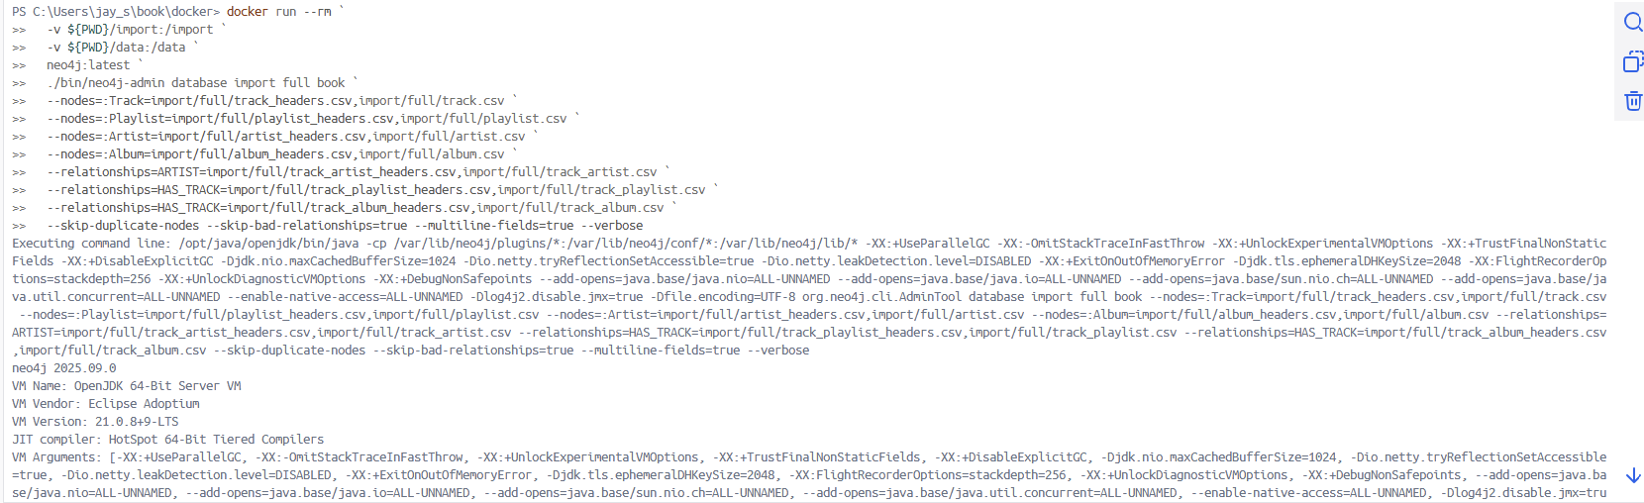

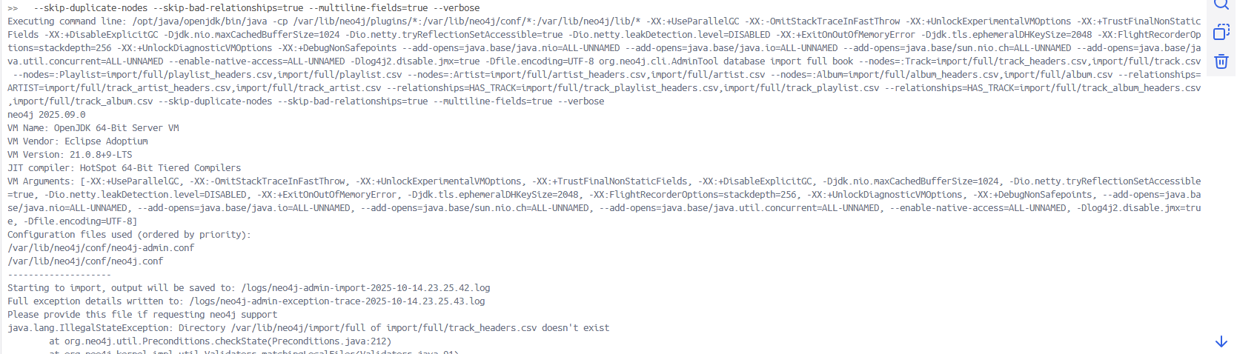

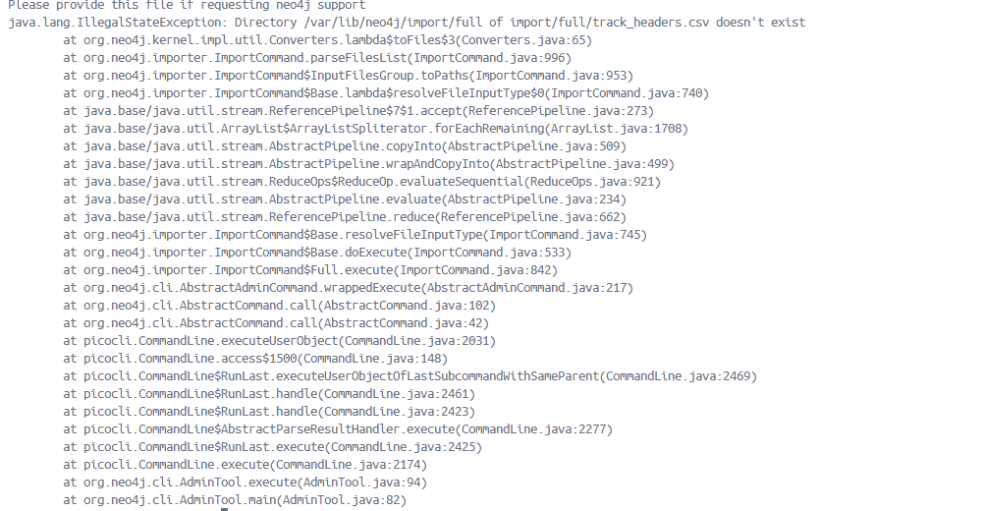

I used docker compose to start:

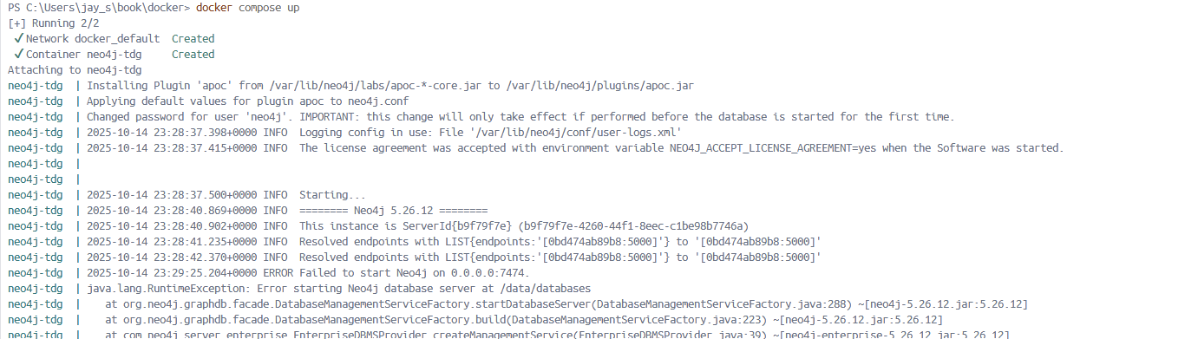

After this my neo4j automatically stopped whenever I started it. So I had to troubleshoot.

The issue is that you're using Neo4j Enterprise Edition (neo4j:5.26-enterprise) which has stricter version compatibility checks. Here are your solutions:

My original docker-compose.yml:
services:
neo4j:
image: neo4j:5.26-enterprise
container_name: neo4j-tdg
ports:
- 7474:7474
- 7687:7687
- 2004:2004
environment:
NEO4J_AUTH: neo4j/password
NEO4J_ACCEPT_LICENSE_AGREEMENT: "yes"
# Uncomment the following line during Chapter 2
#NEO4J_server_memory_heap_max__size: "128M"
NEO4J_PLUGINS: '["apoc"]'
NEO4J_server_metrics_prometheus_enabled: true
NEO4J_server_metrics_prometheus_endpoint: "0.0.0.0:2004"
NEO4J_server_metrics_csv_enabled: false
NEO4J_server_metrics_filter: '*'
volumes:
- "./import:/import"
- "./data:/data"
# Uncomment the following during Chapter 11
# - "./conf/server-logs.xml:/var/lib/neo4j/conf/server-logs.xml"

Solution 1: Use Community Edition (Recommended for learning) [DON’T USE THIS – ONLY ONE DATABASE CAN BE CREATED USING COMMUNITY EDITION]
Change your docker-compose.yml to use the community edition:
yaml
services:
neo4j:
image: neo4j:5.26.0 # or just neo4j:latest
container_name: neo4j-tdg
ports:
- 7474:7474
- 7687:7687
environment:
NEO4J_AUTH: neo4j/password
# Remove enterprise-specific settings
# NEO4J_ACCEPT_LICENSE_AGREEMENT: "yes"
volumes:
- "./import:/import"
- "./data:/data"

Solution 2: Clean Start with Enterprise Edition
If you need Enterprise features, clean everything and start fresh:
powershell
# Stop and remove everything
docker compose down

# Remove the old data directory
Remove-Item -Recurse -Force data

# Create fresh data directory
New-Item -ItemType Directory -Force -Path data
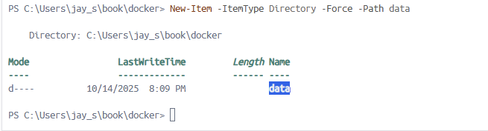

# Run the import with enterprise edition
docker run --rm `
-v ${PWD}/import:/import `
-v ${PWD}/data:/data `
neo4j:5.26-enterprise `
./bin/neo4j-admin database import full book `
--nodes=:Track=import/full/track_headers.csv,import/full/track.csv `
--nodes=:Playlist=import/full/playlist_headers.csv,import/full/playlist.csv `
--nodes=:Artist=import/full/artist_headers.csv,import/full/artist.csv `
--nodes=:Album=import/full/album_headers.csv,import/full/album.csv `
--relationships=ARTIST=import/full/track_artist_headers.csv,import/full/track_artist.csv `
--relationships=HAS_TRACK=import/full/track_playlist_headers.csv,import/full/track_playlist.csv `
--relationships=HAS_TRACK=import/full/track_album_headers.csv,import/full/track_album.csv `
--skip-duplicate-nodes --skip-bad-relationships=true --multiline-fields=true --verbose

If this failed please make sure uncomment the following line from your docker-compse.yml file:

# Uncomment the following line during Chapter 2
NEO4J_server_memory_heap_max__size: "128M"

docker ps | findstr "neo4j"

// stop the running containers
docker compose down

Remove-Item -Recurse -Force data
New-Item -ItemType Directory -Force -Path data

Verify import file path:
PS C:\Users\jay_s\book\docker> docker run --rm -v ${PWD}/import:/import neo4j:latest ls -la /import/full/

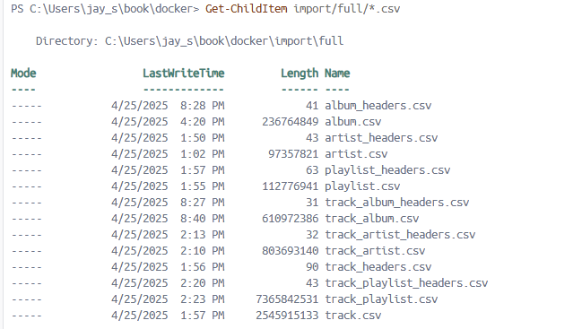
The issue is likely with the volume mounting in the Docker command. Let's fix this:
Make sure to run “docker compose down” to make sure stop all running neo4j containers.

Use absolute paths in PowerShell
docker run --rm `
-v "${PWD}/import:/import" `
-v "${PWD}/data:/data" `
neo4j:latest `
./bin/neo4j-admin database import full book `
--nodes=:Track=/import/full/track_headers.csv,/import/full/track.csv `
--nodes=:Playlist=/import/full/playlist_headers.csv,/import/full/playlist.csv `
--nodes=:Artist=/import/full/artist_headers.csv,/import/full/artist.csv `
--nodes=:Album=/import/full/album_headers.csv,/import/full/album.csv `
--relationships=ARTIST=/import/full/track_artist_headers.csv,/import/full/track_artist.csv `
--relationships=HAS_TRACK=/import/full/track_playlist_headers.csv,/import/full/track_playlist.csv `
--relationships=HAS_TRACK=/import/full/track_album_headers.csv,/import/full/track_album.csv `
--skip-duplicate-nodes --skip-bad-relationships=true --multiline-fields=true --verbose

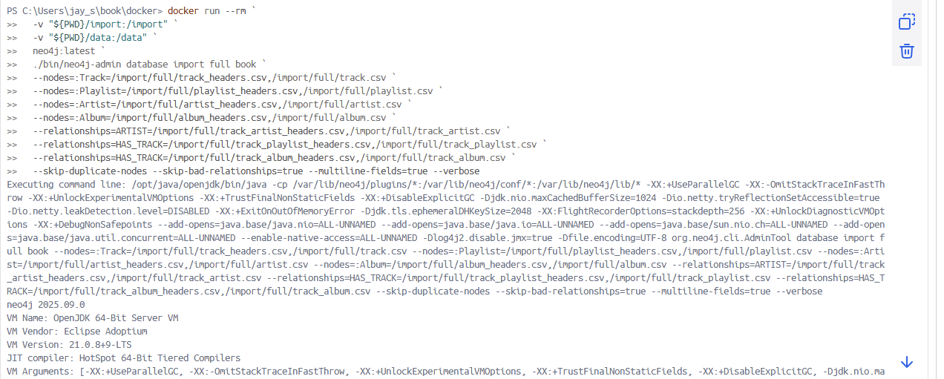

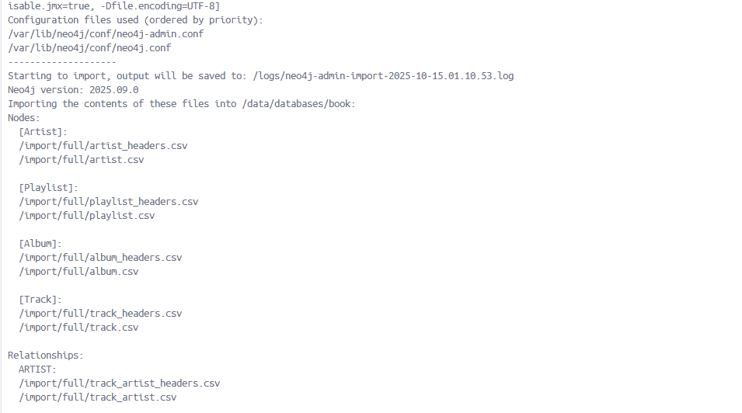

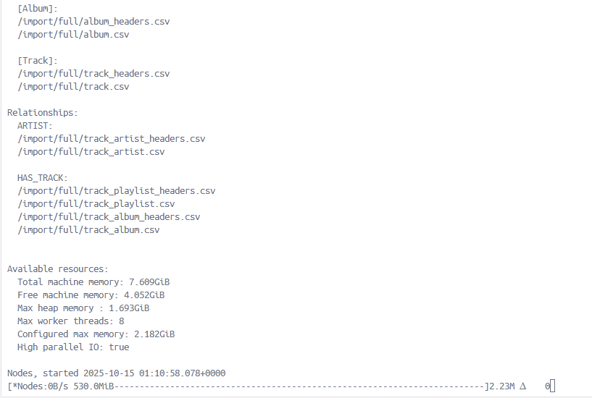

If you stuck (incase you had browser running …etc , you do the following:
Ctrl + c

docker ps | findstr "neo4j"

// stop the running containers
docker compose down

# Clean data directory
Remove-Item -Recurse -Force data -ErrorAction SilentlyContinue
New-Item -ItemType Directory -Force -Path data

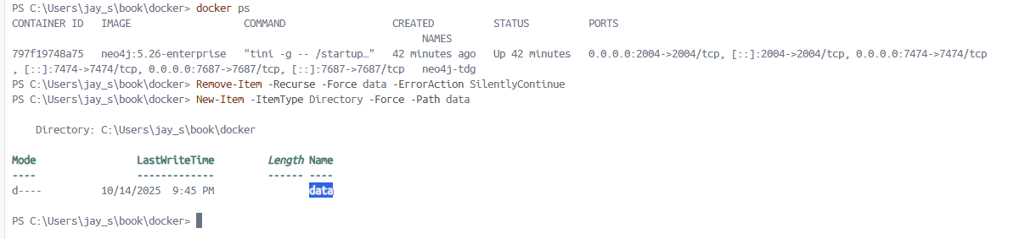

# Run import with memory optimization
docker run --rm `
-v "${PWD}/import:/import" `
-v "${PWD}/data:/data" `
-e NEO4J_dbms_memory_heap_initial__size=2G `
-e NEO4J_dbms_memory_heap_max__size=4G `
neo4j:latest `
/var/lib/neo4j/bin/neo4j-admin database import full book `
--nodes=:Track=/import/full/track_headers.csv,/import/full/track.csv `
--nodes=:Playlist=/import/full/playlist_headers.csv,/import/full/playlist.csv `
--nodes=:Artist=/import/full/artist_headers.csv,/import/full/artist.csv `
--nodes=:Album=/import/full/album_headers.csv,/import/full/album.csv `
--relationships=ARTIST=/import/full/track_artist_headers.csv,/import/full/track_artist.csv `
--relationships=HAS_TRACK=/import/full/track_playlist_headers.csv,/import/full/track_playlist.csv `
--relationships=HAS_TRACK=/import/full/track_album_headers.csv,/import/full/track_album.csv `
--skip-duplicate-nodes --skip-bad-relationships=true --multiline-fields=true --verbose

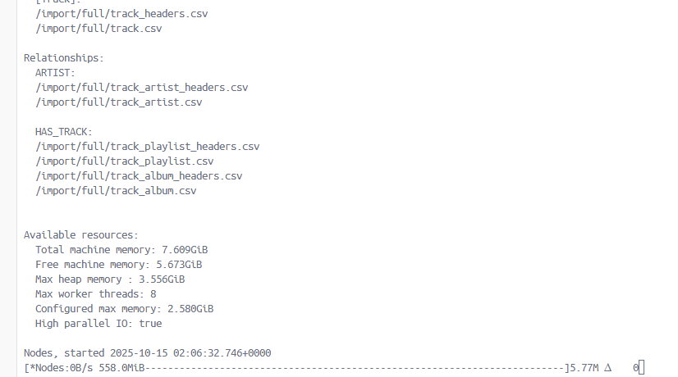

The import should NOT take this long to show progress
Signs it's stuck:
- ∆ 0 means zero nodes processed in the current batch
- No change in the progress bar for 50+ minutes
- Should typically show progress within 5-10 minutes

The issue with the full import is likely memory-related due to the massive size. All attempts FROZEN !!

Stop the import and try these fixes:
Step 1: Stop the current import
Press Ctrl+C
# Clean data directory
Remove-Item -Recurse -Force data -ErrorAction SilentlyContinue
New-Item -ItemType Directory -Force -Path data

# Test with just one node type to verify it works
docker run --rm `
-v "${PWD}/import:/import" `
-v "${PWD}/data:/data" `
neo4j:latest `
/var/lib/neo4j/bin/neo4j-admin database import full book `
--nodes=:Artist=/import/full/artist_headers.csv,/import/full/artist.csv `
--skip-duplicate-nodes --skip-bad-relationships=true --multiline-fields=true --verbose

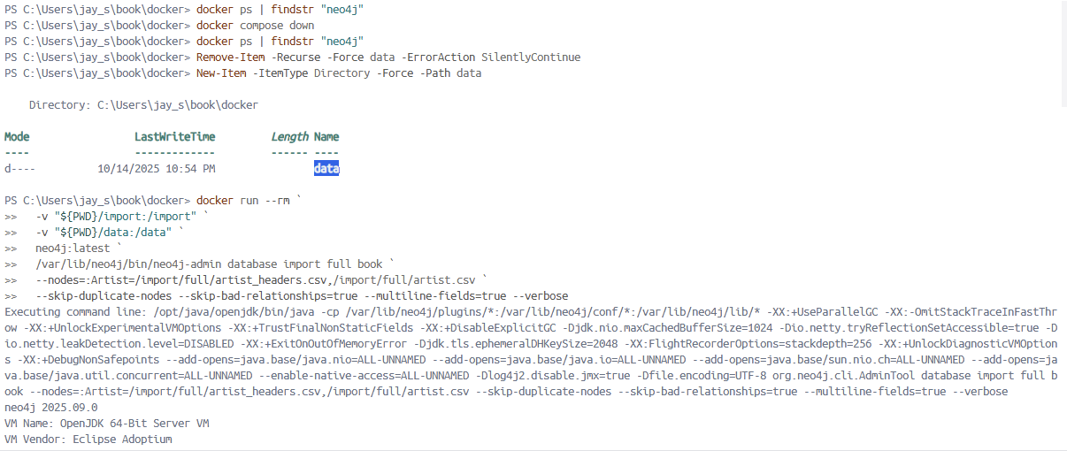

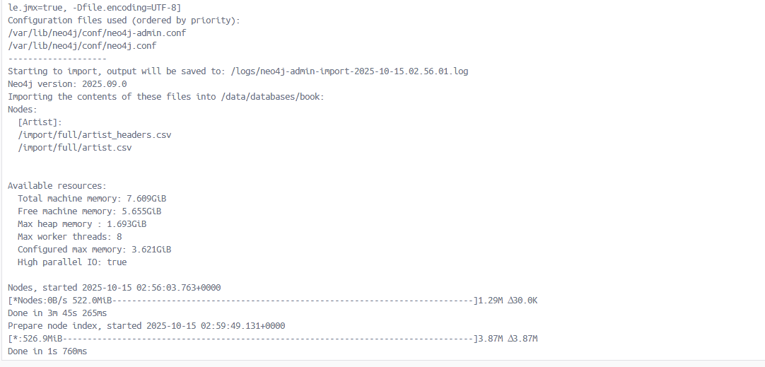

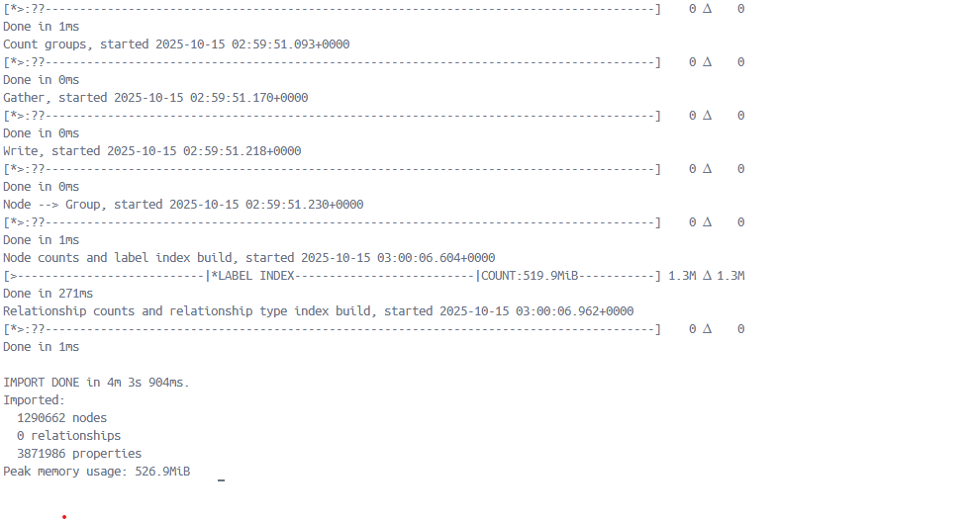

Let's scale up gradually:
Try with 2 node types
powershell
# Clean data directory
Remove-Item -Recurse -Force data -ErrorAction SilentlyContinue
New-Item -ItemType Directory -Force -Path data

# Import Artists and Albums (smaller files)
docker run --rm `
-v "${PWD}/import:/import" `
-v "${PWD}/data:/data" `
neo4j:latest `
/var/lib/neo4j/bin/neo4j-admin database import full book `
--nodes=:Artist=/import/full/artist_headers.csv,/import/full/artist.csv `
--nodes=:Album=/import/full/album_headers.csv,/import/full/album.csv `
--skip-duplicate-nodes --skip-bad-relationships=true --multiline-fields=true --verbose

Again FROZEN !!!

Try with larger memory size:

# Clean data
Remove-Item -Recurse -Force data -ErrorAction SilentlyContinue
New-Item -ItemType Directory -Force -Path data

# Full import with memory settings
docker run --rm `
-v "${PWD}/import:/import" `
-v "${PWD}/data:/data" `
-e NEO4J_dbms_memory_heap_initial__size=4G `
-e NEO4J_dbms_memory_heap_max__size=8G `
neo4j:latest `
/var/lib/neo4j/bin/neo4j-admin database import full book `
--nodes=:Track=/import/full/track_headers.csv,/import/full/track.csv `
--nodes=:Playlist=/import/full/playlist_headers.csv,/import/full/playlist.csv `
--nodes=:Artist=/import/full/artist_headers.csv,/import/full/artist.csv `
--nodes=:Album=/import/full/album_headers.csv,/import/full/album.csv `
--relationships=ARTIST=/import/full/track_artist_headers.csv,/import/full/track_artist.csv `
--relationships=HAS_TRACK=/import/full/track_playlist_headers.csv,/import/full/track_playlist.csv `
--relationships=HAS_TRACK=/import/full/track_album_headers.csv,/import/full/track_album.csv `
--skip-duplicate-nodes --skip-bad-relationships=true --multiline-fields=true --verbose

FROZEN !!

Since bulk import failed, let’s try Use LOAD CSV in Neo4j Browser (Interactive).

Step 1: Clean Setup & Start Neo4j
# Stop any running Neo4j containers
docker compose down

# Remove old data to start fresh
Remove-Item -Recurse -Force data -ErrorAction SilentlyContinue

# Create fresh data directory
New-Item -ItemType Directory -Force -Path data

# Start Neo4j
docker compose up -d

# Wait for it to be ready (30-60 seconds)
Write-Host "Waiting for Neo4j to start..." -ForegroundColor Yellow
Start-Sleep -Seconds 30

# Check if Neo4j is running
docker ps | findstr "neo4j"

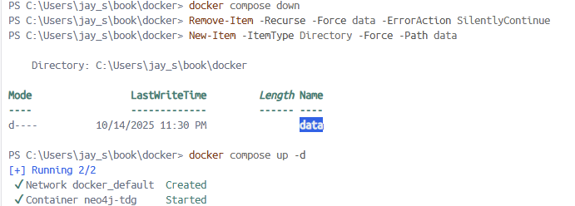

Step 2: Open Neo4j Browser
- Go to http://localhost:7474
- Login with:
  - Username: neo4j
  - Password: password

Step 3: Create Constraints (Run these first for performance)
// Create constraints for better performance
CREATE CONSTRAINT artist_id IF NOT EXISTS FOR (a:Artist) REQUIRE a.id IS UNIQUE;
CREATE CONSTRAINT album_id IF NOT EXISTS FOR (a:Album) REQUIRE a.id IS UNIQUE;
CREATE CONSTRAINT track_id IF NOT EXISTS FOR (t:Track) REQUIRE t.id IS UNIQUE;
CREATE CONSTRAINT playlist_id IF NOT EXISTS FOR (p:Playlist) REQUIRE p.id IS UNIQUE;

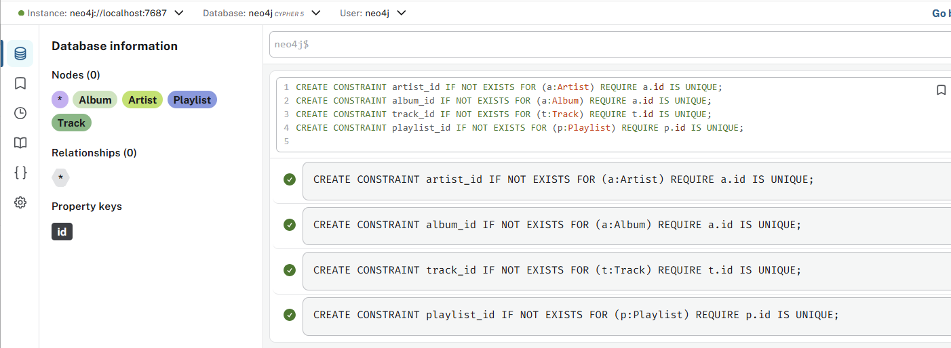
Step 4: Import Nodes (Run in this order)
4.1 Import Artists
LOAD CSV WITH HEADERS FROM 'file:///full/artist.csv' AS row
CREATE (:Artist {id: row.id, name: row.name});

Browser crashed!!

PS C:\Users\jay_s\book\docker> docker logs neo4j-tdg
Installing Plugin 'apoc' from /var/lib/neo4j/labs/apoc-*-core.jar to /var/lib/neo4j/plugins/apoc.jar
Applying default values for plugin apoc to neo4j.conf
Changed password for user 'neo4j'. IMPORTANT: this change will only take effect if performed before the database is started for the first time.
2025-10-15 03:48:49.334+0000 INFO Logging config in use: File '/var/lib/neo4j/conf/user-logs.xml'
2025-10-15 03:48:49.346+0000 INFO The license agreement was accepted with environment variable NEO4J_ACCEPT_LICENSE_AGREEMENT=yes when the Software was started.

2025-10-15 03:48:49.407+0000 INFO Starting...
2025-10-15 03:48:55.873+0000 INFO ======== Neo4j 5.26.12 ========
2025-10-15 03:48:55.966+0000 INFO This instance is ServerId{7e8f3c46} (7e8f3c46-33fa-4377-bae7-a06efa9ef342)
2025-10-15 03:48:56.621+0000 INFO Resolved endpoints with LIST{endpoints:'[12843f6a4dea:5000]'} to '[12843f6a4dea:5000]'
2025-10-15 03:48:58.782+0000 INFO Resolved endpoints with LIST{endpoints:'[12843f6a4dea:5000]'} to '[12843f6a4dea:5000]'
2025-10-15 03:49:22.071+0000 INFO Default database 'neo4j' is created
2025-10-15 03:49:26.372+0000 INFO Anonymous Usage Data is being sent to Neo4j, see https://neo4j.com/docs/usage-data/
2025-10-15 03:49:26.402+0000 INFO Started publishing Prometheus metrics at http:///[0:0:0:0:0:0:0:0]:2004/metrics
2025-10-15 03:49:26.597+0000 INFO Bolt enabled on 0.0.0.0:7687.
2025-10-15 03:49:26.609+0000 INFO Bolt (Routing) enabled on 0.0.0.0:7688.
2025-10-15 03:49:29.969+0000 INFO HTTP enabled on 0.0.0.0:7474.
2025-10-15 03:49:29.971+0000 INFO Remote interface available at http://localhost:7474/
2025-10-15 03:49:29.981+0000 INFO id: 5385B8EF27C5E7DC5E2A8DCC70A2E2E4B57BA49577F9B989D0884A61ED0AFD81
2025-10-15 03:49:29.985+0000 INFO name: system
2025-10-15 03:49:29.985+0000 INFO creationDate: 2025-10-15T03:49:01.421Z
2025-10-15 03:49:29.986+0000 INFO Started.

Exception: java.lang.OutOfMemoryError thrown from the UncaughtExceptionHandler in thread "req-rsp-timeout-task"

Exception: java.lang.OutOfMemoryError thrown from the UncaughtExceptionHandler in thread "neo4j.Scheduler-1"

Exception: java.lang.OutOfMemoryError thrown from the UncaughtExceptionHandler in thread "HTTP-Dispatcher"

Exception: java.lang.OutOfMemoryError thrown from the UncaughtExceptionHandler in thread "pool-2-thread-1"

Exception: java.lang.OutOfMemoryError thrown from the UncaughtExceptionHandler in thread "idle-timeout-task"

Exception: java.lang.OutOfMemoryError thrown from the UncaughtExceptionHandler in thread "neo4j.VmPauseMonitor-1"

Exception: java.lang.OutOfMemoryError thrown from the UncaughtExceptionHandler in thread "qtp160625428-110"

Exception: java.lang.OutOfMemoryError thrown from the UncaughtExceptionHandler in thread "qtp160625428-105"

Exception: java.lang.OutOfMemoryError thrown from the UncaughtExceptionHandler in thread "Log4j2-TF-3-Scheduled-1"

Exception: java.lang.OutOfMemoryError thrown from the UncaughtExceptionHandler in thread "qtp160625428-113"

Out of Memory Error! The container is crashing because it's running out of memory during the import. Your dataset is too large for the default memory settings.

Create a file at C:\Users\jay_s\.wslconfig with this content:

powershell
# Create the .wslconfig file
@"
[wsl2]
memory=6GB
processors=2
swap=2GB
localhostForwarding=true
"@ | Out-File -FilePath "$HOME\.wslconfig" -Encoding ASCII

# Check if file exists and view its contents
Get-Content "$HOME\.wslconfig"

Restart WSL and Docker
# Shutdown WSL
wsl --shutdown

# Wait a few seconds
Start-Sleep -Seconds 5

# Restart Docker Desktop (manually)
# - Close Docker Desktop from system tray
# - Reopen Docker Desktop

Update your docker-compose.yml with conservative memory settings
# Conservative memory settings for limited environment
NEO4J_dbms_memory_heap_initial_size: "1G"
NEO4J_dbms_memory_heap_max_size: "2G"

Verify the new memory limits
# Check WSL status
wsl --status

# Start your Neo4j container
docker compose up -d

# Check if it's running
docker ps

Clean the database if needed:
// Delete all data
MATCH (n) DETACH DELETE n;

// Drop constraints
DROP CONSTRAINT artist_id;
DROP CONSTRAINT album_id;
DROP CONSTRAINT track_id;
DROP CONSTRAINT playlist_id;

Use very conservative import batches
Once Neo4j is running, use tiny batches in the browser:

// Import artists in small batches
CALL apoc.periodic.iterate(
"LOAD CSV WITH HEADERS FROM 'file:///full/artist.csv' AS row RETURN row",
"CREATE (:Artist {id: row.id, name: row.name})",
{batchSize: 1000, parallel: false}
);

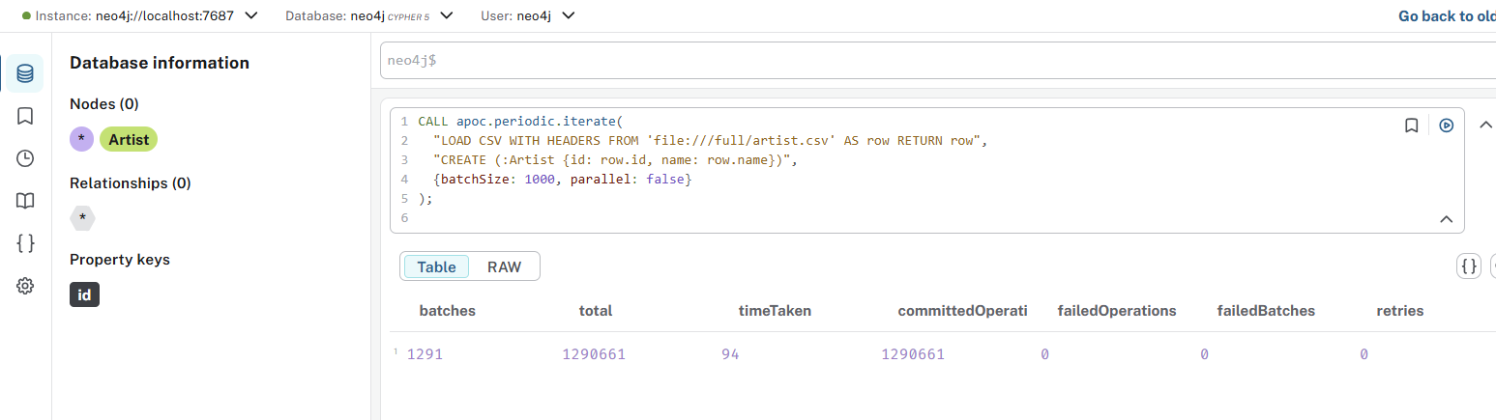

// Verify no duplicates exist
MATCH (a:Artist)
WITH a.id AS artistId, count(*) AS count
WHERE count > 1
RETURN artistId, count
LIMIT 10;

To Match neo4j-admin import Logic Exactly:
Step 1: Create constraints with existence checks
cypher
// Drop if exists, then create
DROP CONSTRAINT artist_id IF EXISTS;
CREATE CONSTRAINT artist_id FOR (a:Artist) REQUIRE a.id IS UNIQUE;

DROP CONSTRAINT album_id IF EXISTS;
CREATE CONSTRAINT album_id FOR (a:Album) REQUIRE a.id IS UNIQUE;

DROP CONSTRAINT track_id IF EXISTS;
CREATE CONSTRAINT track_id FOR (t:Track) REQUIRE t.id IS UNIQUE;

DROP CONSTRAINT playlist_id IF EXISTS;
CREATE CONSTRAINT playlist_id FOR (p:Playlist) REQUIRE p.id IS UNIQUE;

Step 2: Import nodes with MERGE (equivalent to --skip-duplicate-nodes)
cypher
// 1. Artists
CALL apoc.periodic.iterate(
"LOAD CSV WITH HEADERS FROM 'file:///full/artist.csv' AS row RETURN row",
"MERGE (a:Artist {id: row.id}) SET a.name = row.name",
{batchSize: 1000}
);

// 2. Albums
CALL apoc.periodic.iterate(
"LOAD CSV WITH HEADERS FROM 'file:///full/album.csv' AS row RETURN row",
"MERGE (a:Album {id: row.id}) SET a.title = row.title, a.genre = row.genre",
{batchSize: 1000}
);

Returned error:
Neo.ClientError.Procedure.ProcedureCallFailed
Failed to invoke procedure `apoc.periodic.iterate`: Caused by: org.neo4j.csv.reader.DataAfterQuoteException: At /import/full/album.csv @ position 20133692 - there's a field starting with a quote and whereas it ends that quote there seems to be characters in that field after that ending quote. That isn't supported. This is what I read: 'Christmas In New Orleans ""AA'

// 3. Playlists
CALL apoc.periodic.iterate(
"LOAD CSV WITH HEADERS FROM 'file:///full/playlist.csv' AS row RETURN row",
"MERGE (p:Playlist {id: row.id}) SET p.name = row.name",
{batchSize: 1000}
);

// 4. Tracks (this is the big one)
CALL apoc.periodic.iterate(
"LOAD CSV WITH HEADERS FROM 'file:///full/track.csv' AS row RETURN row",
"MERGE (t:Track {id: row.id}) SET t.title = row.title, t.duration = toInteger(row.duration)",
{batchSize: 500}
);

All attempts FAILED!!!

Now I am trying different method:

Step 1: Complete Cleanup
powershell
# Stop everything
docker compose down

# Remove ALL Docker containers, images, volumes
docker system prune -a -f --volumes

# Clean directories
Remove-Item -Recurse -Force data,import -ErrorAction SilentlyContinue

# Recreate directories
New-Item -ItemType Directory -Force -Path data,import/full

Step 2: Download Fresh Dataset
powershell
# Download the dataset
Invoke-WebRequest "https://downloads.graphaware.com/neo4j-the-definitive-guide/dataset.zip" -OutFile "dataset.zip"

# Extract
Expand-Archive -Path "dataset.zip" -DestinationPath "." -Force

# Verify files
Get-ChildItem import/full/*.csv | Select-Object Name, Length

Step 3: Fix WSL Memory Limits
Create C:\Users\jay_s\.wslconfig:
ini
[wsl2]
memory=12GB
processors=4
swap=4GB
localhostForwarding=true
Then restart:
powershell
wsl --shutdown
# Wait 30 seconds, then restart Docker Desktop manually

Step 4: Use Optimized Docker Setup
Create a new docker-compose.yml:
yaml
services:
neo4j-import:
image: neo4j:5.26.0
container_name: neo4j-import
volumes:
- "./import:/import"
- "./data:/data"
command: [
"sh", "-c",
"./bin/neo4j-admin database import full book
--nodes=:Track=/import/full/track_headers.csv,/import/full/track.csv
--nodes=:Playlist=/import/full/playlist_headers.csv,/import/full/playlist.csv
--nodes=:Artist=/import/full/artist_headers.csv,/import/full/artist.csv
--nodes=:Album=/import/full/album_headers.csv,/import/full/album.csv
--relationships=ARTIST=/import/full/track_artist_headers.csv,/import/full/track_artist.csv
--relationships=HAS_TRACK=/import/full/track_playlist_headers.csv,/import/full/track_playlist.csv
--relationships=HAS_TRACK=/import/full/track_album_headers.csv,/import/full/track_album.csv
--skip-duplicate-nodes --skip-bad-relationships=true --multiline-fields=true --verbose"
]

Step 5: Run the Import
powershell
# Run the import container
docker compose up neo4j-import

# This will run the import and then exit

Leave it running even if it seems slow. Large imports can take:
- Node import: 30 minutes - 2 hours
- Relationship import: 1-4 hours
- Total: 2-6 hours for your dataset size

Run in background (so you can't accidentally stop it)
powershell
docker compose up -d neo4j-import

# Monitor progress without interrupting
docker logs -f neo4j-import

Use nohup style (most robust)
powershell
# Run in background and detach completely
Start-Process -NoNewWindow -FilePath "docker" -ArgumentList "compose", "up", "neo4j-import"

# Check progress later
docker logs neo4j-import

What to expect during successful import:
- Nodes phase: Progress bar will show nodes counting up
- Relationships phase: New progress bar for relationships
- Final statistics: Summary of imported nodes/relationships
- Container will exit automatically when done

To monitor without interrupting:
powershell
# In one PowerShell window - start the import
docker compose up neo4j-import

# In another PowerShell window - check progress
docker logs -f --tail 50 neo4j-import

If you need to stop it properly later:
powershell
# Stop gracefully (don't use Ctrl+C)
docker compose down

If you interrupted the import You must clean before restarting:
powershell
# Stop everything
docker compose down

# Remove the corrupted/incomplete data
Remove-Item -Recurse -Force data -ErrorAction SilentlyContinue

# Recreate fresh data directory
New-Item -ItemType Directory -Force -Path data

# Then restart the import
docker compose up neo4j-import

